New Head Coach Oysters 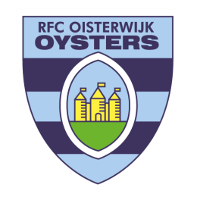

The Oisterwijk Oysters are thrilled to announce the appointment of Daniel Geurs as the new head coach for our senior team. Daniel brings a wealth of experience and a proven track record of success in both Rugby League and Rugby Union, having had an illustrious playing career across Australia, the Netherlands, and the UK.

After a five-year hiatus from the sport, Daniel transitioned to coaching, earning a Level 3 World Rugby accreditation. Over the past eight years, he has made significant contributions as an assistant coach in the prestigious Shute Shield, working with teams such as the Warringah Rats, Penrith Emus, Western Sydney Two Blues, and the U20’s Gordon Highlanders. Additionally, he has coached representative sides including NSW Fiji and Australian Tonga in various tournaments.

Daniel's international coaching credentials are impressive. He spent two years as the head coach of the Bedok Kings and served as the defense coach for the Singapore National team in the Division 1 Asian Cup.

Coaching Career Highlights:
- 2017: Warringah Rats – Champions
- 2017: NSW Fiji – Champions
- 2018: Warringah Rats – Grand Finalists
- 2018: NSW Fiji – Champions
- 2019: Singapore National team – Asian Cup Finalists
- 2022: Western Sydney Two Blues reserve grade – reached the finals for the first time in 12 years

Beyond the pitch, Daniel has demonstrated leadership in sports administration, serving as General Manager for both the Western Sydney Two Blues and the Penrith Emus. He has also successfully engaged in several sports-related commercial ventures.

Daniel’s coaching philosophy is built on the principles of Pride, Determination, Commitment, maintaining a Down to Earth attitude (no egos), and fostering a family environment. We are confident that his approach and extensive experience will be invaluable to our senior teams and club.

Please join us in welcoming Daniel to the Oisterwijk Oysters family. Daniel will arrive at the 26th of June. We look forward to an exciting and successful season under his leadership.

