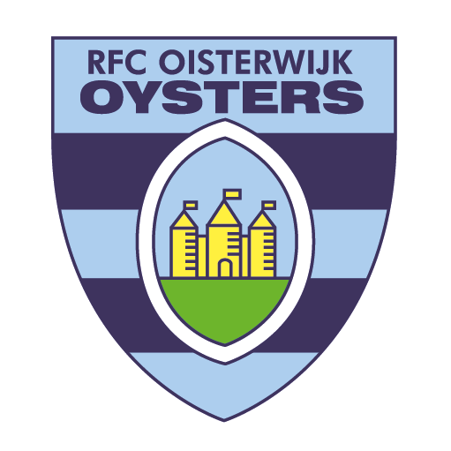

Interview Website Oysters

Name: Matias Pfaff

Age: 25 years

Nationality: Argentinian

Position: Number 10-15

Why did you choose the Oysters Matti?

I want to continue to learn, develop, add experiences and experience and improve, as a person and rugby player.?

Did you already know the Oysters?

No, never heard of it, but from the Netherlands.

Which clubs have you played for?

- DOAM, Club DAOM, or simply DAOM, is an Argentine sports club located in the Flores neighborhood of Buenos Aires. The club hosts a variety of sports and activities such as baseball, hockey, roller skating, rugby, tennis and volleyball. The rugby team currently plays in Primera C, the fourth division of the URBA league system.

- Barbarians RFC in Australia

- University of the Sunshine Coast (Australia)

What is your first impression of Oisterwijk and the Oysters?

The Oysters is a nice family club, with good people always ready to help. Oisterwijk is a beautiful city and the Netherlands a beautiful, clean and well-organized country.

Do you dare to make a prediction? Oysters remain in the Ereklasse because:

The Oysters want to grow, compete and win. We are going to work every day to realize that

Thank you for this interview Matias

